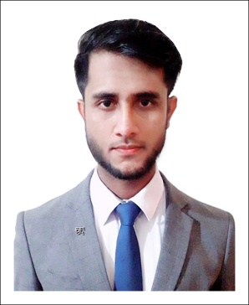**CURRICULUM VITAE**

**Alamin**

Contact number: +88018-75780315

Email: [alaminbhuyan321@gmail.com](mailto:alaminbhuyan321@gmail.com)

LinkedIn: [https://www.linkedin.com/in/al-amin/](https://www.linkedin.com/in/al-amin-6a3100269/)

Address: Faidabad Chowrasta, Uttara, Sector-6, Dhaka-1230

**CAREER OBJECTIVE**

To obtain a customer service or call center position where I can utilize my communication skills and provide exceptional customer service while gaining experience in the field.

**PERSONAL INFORMATION**

Father’s Name : Mostafa Kamal

Mother’s Name : Mahabuba Begum

Mailing Address : Faidabad Chowrasta, Uttara, Sector-6, Dhaka-1230.

Permanent Address : Vill- Manikkandi, P.O.- Islamabad, Tana-Titas, District- Comilla

Date of birth : 04-June-1999

Marital status : Unmarried

Religion : Islam

Nationality : Bangladesh by birth

**EDUCATIONAL QUALIFICATION**

1. **B.SC. IN COMPUTER SCIENCE AND ENGINEERING**

University : Uttara University

Major : Computer Science & Engineering

Passing Year : 2022

Result : CGPA-3.93 Out of 4.00

1. **HIGHER SECONDARY SCHOOL CERTIFICATE**

Institute : Mehnaz Hossen Mim Adarsha College

Group : Science

Board : Comilla

Passing Year : 2017

Result : GPA-3.25 Out of 5.00

1. **SECONDARY SCHOOL CERTIFICATE**

Institute : Jonab Ali High School

Group : Science

Board : Comilla

Passing Year : 2015

Result : GPA-4.61 Out of 5.00

**SKILLS**

* Strong communication skills, both verbal and written
* Excellent problem-solving and critical-thinking abilities
* Ability to handle multiple tasks and work in a fast-paced environment
* Proficient in Microsoft Office (Word, Excel, PowerPoint)
* Experience using customer relationship management (CRM) software
* Bilingual in [English]



|  |
| --- |
| **Signature** |